1.5/1
PASSION FOR SUCCESS
Swicofil AG
CH-6021 Emmenbrücke

UNIFORMITY OF GOODS DESCRIPTION

1. Validity

For a l l correspondance, offers, order confirmations, invoices and delivery notes concerning products sold by Swicofil AG.

This concerns also the work of all a l l representatives and agents.

2. Base

- Prescriptions of the laws
- Guide lines and rules of international authorities such as:
EFTA, EU, BISFA, CIRFS, DIN, ETC.

3. Structure of goods description

Our goods are always described in the following order:

1st line: - Fiber type (material) Polyamide 6.6 PA 6.6
Polyamide 6 PA 6
Polyester PES
Viscose CV
- ev. brand name
2nd line: - Material state pre-oriented yarn POY
flat yarn FOY or FEI or FDY
Texturizing text. Set (FTF or double heater)
text. HE (FT or single heater)
text. Stretch (torque)
airtextured
KdK – Knit de Knit
BCF
high tenacity h.t.
medium tenacity m.t.
monofilament
flock cutflock or ground flock
tow
fibers loose fibers or tops
spun yarn
flocked yarn
braid
- Color

3rd line: - Type number if the supplier uses a type description numbering system
- Dullness see abbreviations
- Cross-section see abbreviations

4th line: - Count construct: consisting of the following pieces of information:
- Count in dtex (for POY also spinning count in brackets)
- filaments / cutlength / diameter / Nm / ktex of tow
- initial twist direction
- plying
- twist direction + number of twists per meter
- intermingling information
- quality

5th line: Finishing of product - Sizing details
- finissage shrinking/heat setting
- reduced oiling
- tow treatment
- humidity information
This line can also be used for a second 4th line description as eg. in the case of
textured yarn – i.e. to express the second intial twist direction (S) and (Z) if both
S+Z are sold.

6th line: Yarn carrier description and ev. net weight per carrier

7th line: in correspondance, on orders and confirmations not compulsory
- Lot
- Recipe

add.lines: to provide further details such as various colors, warpknitting and weaving
beam details etc. Example:

Sized on polyester basis
on customers weavers beams
for .... airjet looms, modell ....
number of ends 7'200
dresses width 170 cm
yarn length per beam 5'000 m
leases 2B/1E

Examples of the goods descriptions used in an inquiry or offer

Material state | line | Goods description example | How does it look like?
Polymer | 1st line  2nd line  3rd line  4th line  5th line  6th line  7th line | Polyester  Polymer rawwhite  type XYZ bright  -  heat resistant, UV protected  in big bags  merge 111 | 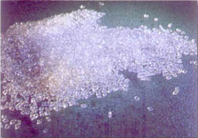
POY | 1st line  2nd line  3rd line  4th line  5th line  6th line  7th line | Polyester  POY rawwhite  type 218 semidull round  dtex 78 (110) f 24, 1a  -  Y 94/290 of 22,9 kgs  merge 111 recipe 88537 | 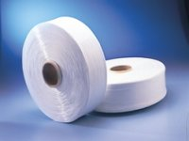
flat  (FOY/FEI or  cops yarn) | 1st line  2nd line  3rd line  4th line  5th line  6th line  7th line | Polyester  FEI rawwhite  type T563 bright trilobal  dtex 100 f 33, int. 1a  -  Y 64/290 of 9,7 kgs  merge 69a7 | 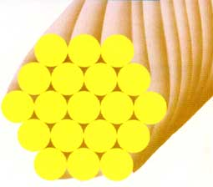
air textured | 1st line  2nd line  3rd line  4th line  5th line  6th line  7th line | Polyester  airtextured rawwhite  type bright trilobal  dtex 167 f 144 x 1,1a  -  Y 69/290 of 5,5 kgs  merge 3308 recipe AAF8 | 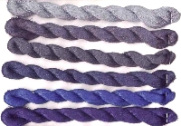
textured HE | 1st line  2nd line  3rd line  4th line  5th line  6th line  7th line | Polyamide 6.6  textured HE rawwhite  type 2044 semidull round  dtex 78 f 23 (S)+(Z) x 1, 1a  -  Y 69/290 of 2,5 kgs  merge 707 | 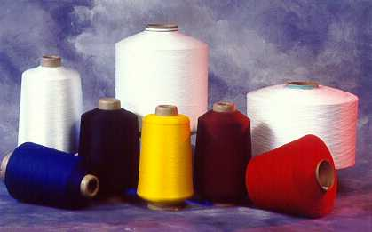
textured Set | 1st line  2nd line  3rd line  4th line  5th line  6th line  7th line | Polyamide 6.6  textured Set rawwhite  type 2039 semidull round  dtex 78 f 24 (SZ) x 2 int, 1a  -  Y 69/290 of 2,5 kgs  merge 707
Knit de Knit | 1st line  2nd line  3rd line  4th line  5th line  6th line  7th line | Polyamide 6.6  Knit de knit rawwhite  type bright round  dtex 78 f 24 x 1, 1a  -  Y 69/290 of 2,5 kgs  merge 707 | 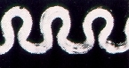

Material state | line | Goods description example
Fancy yarn | 1st line  2nd line  3rd line  4th line  5th line  6th line  7th line | Polyester Mousseline  Fantasie rawwhite  Art 2219 semidull round  dtex 185 (Nm 54/55) S/Z, 1a  -  ZH 56/230 of 2,9 kgs  merge 707 | 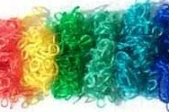
Mixed yarn | 1st line  2nd line  3rd line  4th line  5th line  6th line  7th line | Mixed yarn AC/CV 50/50 granite  mixed yarn rawwhite  Art 5065  dtex 185 (Nm 54/55), 1a  -  Cones 230 of 1,5 kgs  merge 707
High tenacity | 1st line  2nd line  3rd line  4th line  5th line  6th line  7th line | Polyamide 6  high tenacity, olive green 5933  type 051 bright round  dtex 940 f 140 x 3 Z 150 tpm, 1a  shrunk  Y 69/290 of 5,0 kgs  merge 707 | 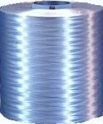
Monofilament | 1st line  2nd line  3rd line  4th line  5th line  6th line  7th line | Polyethylene ESMOFIL  monofilament spundyed orange 5933  bright round  0,160 mm (dtex 193), 1a  high UV protection  Y 90/290 of 4,5 kgs | 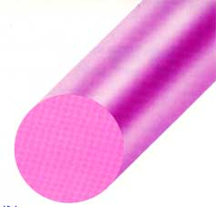
Flock | 1st line  2nd line  3rd line  4th line  5th line  6th line  7th line | Polyamide 6.6  cutflock flockdyed red 509  type 2099 semidull round  dtex 1,7 / 0,75 mm, 1a  high activation  in bags of 20 kgs inside cartons  merge …, recipe ….
Tow | 1st line  2nd line  3rd line  4th line  5th line  6th line  7th line | Polyamide 6.6  tow rawwhite  type N220 bright opal  dtex 1,7 (300 ktex), 1a  crimped  carton boxes of 300 kgs  merge 707 | 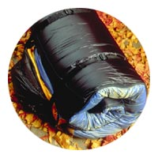
Fibers | 1st line  2nd line  3rd line  4th line  5th line  6th line  7th line | Polypropylene  fibre rawwhite  type 33 semidull round  dtex 3,3 / 38 mm, 1a  -  Bales of 250 kgs  merge

Material state | line | Goods description example
Spun | 1st line  2nd line  3rd line  4th line  5th line  6th line  7th line | Polyester  spun rawwhite  type 220 semidull round  dtex 167 (NE 30/1), 1a  -  cones of 2,5 kgs  merge | 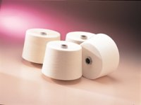
Tops | 1st line  2nd line  3rd line  4th line  5th line  6th line  7th line | Polyester  tops rawwhite  type semidull round  dtex 2,4 / 38 mm (120 ktex), 1a  -  in drums of 50 kgs  lot … recipe … | 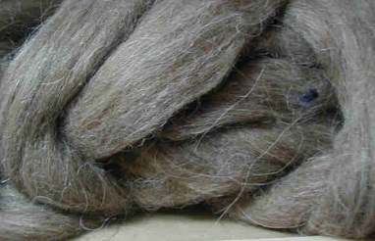
Flocked yarn | 1st line  2nd line  3rd line  4th line  5th line  6th line  7th line | Polyamide 6.6 RALLYTEX  Flockgarn dyed black  semidull round  Nm 4.0 (dtex 2700), 1a  -  Cones 3’30 of 2,5 kgs  merge | 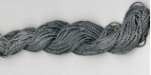
BCF textured | 1st line  2nd line  3rd line  4th line  5th line  6th line  7th line | Polyamide 6.6  textured BCF deep  type D356 semidull trilobal  dtex 880 f 16 x 1, 1a  -  Y 69/290 of 5,5 kgs  merge | 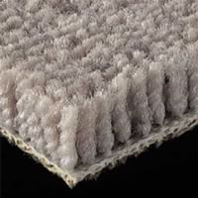
textured Stretch | 1st line  2nd line  3rd line  4th line  5th line  6th line  7th line | Polyamide 6.6  textured Stretch rawwhite  type 978 semidull round  dtex 11 f 7 (S)+(Z) x 1, 1a  -  Y 69/290 of 1,5 kgs  merge …recipe …
Medium tenacity | 1st line  2nd line  3rd line  4th line  5th line  6th line  7th line | Polypropylene RIFIL  medium tenacity, spundyed orange  type bright round  dtex 470 f 100 Z 100 tpm, 1a  heat set  Y 69/290 of 5,5 kgs  merge
Braid | 1st line  2nd line  3rd line  4th line  5th line  6th line  7th line | Polyamide 6.6  braid rawwhite  semidull round  250 x 16 Fäden (dtex 2700), 1a  -  flanged bobbins of 0,5 kgs  merge | 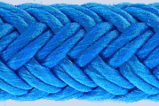

Material state | line | Goods description example
Others | 1st line  2nd line  3rd line  4th line  5th line  6th line  7th line | Cotton  linters rawwhite  -  -  -  in bags of 30 kgs  -

Swicofil AG

