1
PASSION FOR SUCCESS
Swicofil AG
CH-6021 Emmenbrücke

A B B R E V I A T I O N S

BISFA Bureau International pour la Standardisation de la Rayonne et
des Fibres synthétiques
CIRFS Comité International de la Rayonne et des Fibres Synthétiques

Article description:
Brigthness | sb. |  | superbright | (superglänzend) | 0,00 % TiO2
 | br. |  | bright | (glänzend) | 0,02 - 0,04 % TiO2
 | sd. |  | semidull | (halbmatt) | 0,40 % TiO2
 | du. |  | dull | (matt) | 1,20 – 1,50 % TiO2 + higher
 | bl. |  | black spundyed bright | (spinngef. schwarz glzd)
 | in. |  | ingrain (black/white) | (schwarz/weiss)
 | ba. |  | basic dyeable/cationic | (basisch färbbar)
 | sf. |  | spundyed (non black) | (alle and.Spinnfarben)
 | mx. |  | mixed filaments | (Filament Mischungen)

Cross- | .rd |  | round
Section | .op |  | opal
 | .fl |  | flat
 | .tr | Δ | trilobal (massif trilobal)
 | .tb |  | trilobal (profile trilobal)
 | .ml |  | multilobal
 | .pl |  | pentalobal
 | .hx |  | hexalobal
 | .oc |  | octalobal
 | .sp | .. | special cross-section
 | .hl |  | hollow fiber
 | .ql |  | maple leaf cross-section
 | .us | U | U – shape
 | .ys | Y | Y - shape
 | .sq |  | square shape
 | .rc |  | rectangular shape
 | .ss |  | side by side
 | .rs | 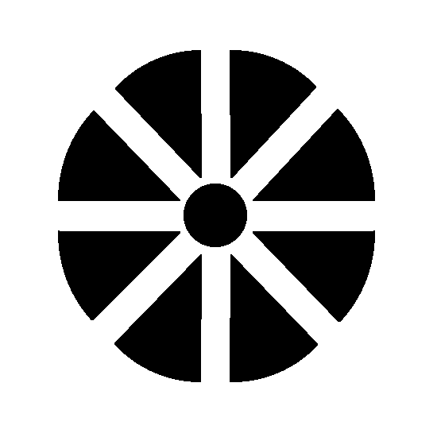 | round splittable
 | .mi |  | mixed polymer
 | .si |  | sea + island (PET and Co-PET)
 | .co |  | conjugate

Textured yarn grades

Pin textured

Grade BEAG type Crimp contraction Texturizing Explanation
Set 1 2030 10% double heater setted yarn
Set 2 2031 20-25% double heater
Set 3 2032 35% double heater
ME 2033 40-45% double heater medium elastic
HE 2034 45-75% single heater high elastic
Stretch … …. low torque textured

Friction textured

Grade BEAG type Crimp contraction Texturizing Explanation
Set 2036 20-25% double heater setted yarn
HE 2039 max. 60% single heater high elastic

DSP dimensional stable polyester
FOY Fully Oriented Yarn
POY Partially Oriented Yarn
LOY Low Oriented Yarn
FDY Fully drawn yarn = FOY
DTY Draw textured yarn (friction twisted)
SDY Super drawn yarn (FOY)

Or Origin
F France
D Germany
I Italy
E Spain
GB Great Britain
CH Switzerland
NL Netherlands
TR Turkey
AT Austria
PL Poland
CN China
RO Rumania
SI Slovenia
LV Latvia
SK Slovakia

Den Denier (dtex x 0,9)
dtex Decitex (grams per 10000 meters)
ECC European cotton count (Ne)
dpf denier per filament or dtex per filament

Put up Presentation of yarn / yarn carrier
Y Cylinders without top end rounded (the figures behind indicate the
interior diameter of the cyl. and the height of the cyl., eg 56/230)
ZH Cylinders with top end rounded to ensure perfect running off
SH Shrinkage cylinders for uptwisted yarns
CL Cones
CB Cones
TKB Warp knitting beams (the figures behind indicate the
measurements of the warpknitting beam in cm, eg 54/106)
WKB Weaving beams

Cops 340 Cops of 340 mm length
Cops 400 Cops of 400 mm length
Cops 420 Cops of 420 mm length
Cops 460 Cops of 460 mm length with slightly bigger cops diameter

