18GT/1

Swicofil AG
CH-6021 Emmenbrücke

Yarn carriers Edition 23.07.14

Yarn carrier type | Design |  | Description parameters
Cops | 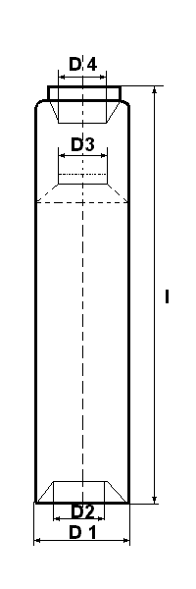 | 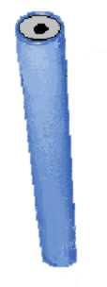 | D1 – D 4:  Various diameters according to drawing  L:  Overall length of cops
Cones | 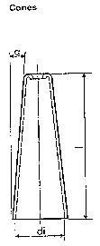 | 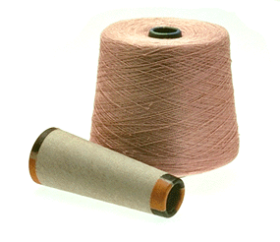 | Di:  Interior diameter at bottom of cone  L:  Overall length of cone  :  Angle of con
Cylinders Y | 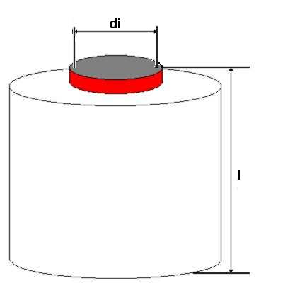 | 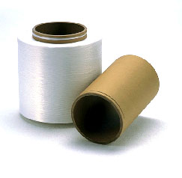 | Di:  Interior diameter at bottom of cylinder  L:  Overall length of cylinder
Cylinder ZH | 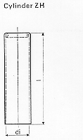 | 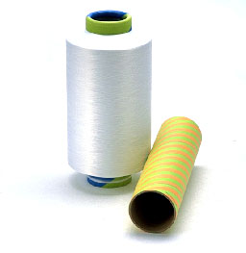 | Di:  Interior diameter at bottom of cylinder  L:  Overall length of cylinder  This cylinder has a rounded off top to facilitate easy unwinding
Flanged bobbin RK | 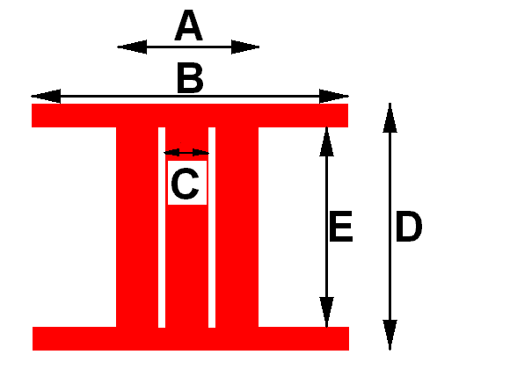 | 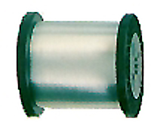 | A – E:  Various diameters according to drawing
Weaving beam traditional shuttle looms WKB | 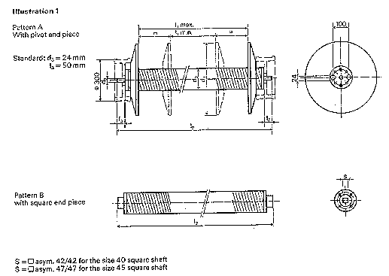 | 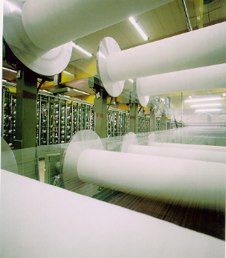 | L1:  Distance between flanges – min/max  L2:  Overall length of centerpiece
Weaving beam airjet looms WKB | 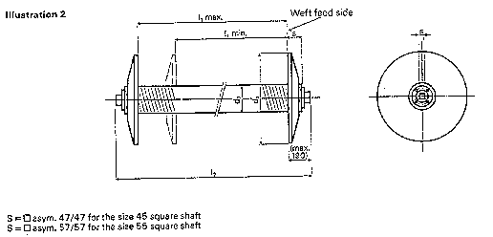 |  | L1:  Distance between flanges – min/max  L2:  Overall length of centerpiece
Weaving beam Nissan waterjet looms WKB | 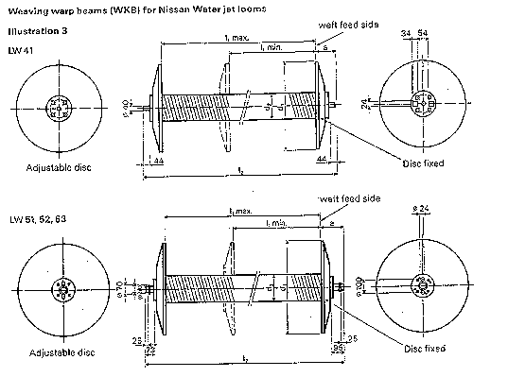 |  | L1:  Distance between flanges – min/max  L2:  Overall length of centerpiece
Weaving beam Sulzer PU looms WKB | 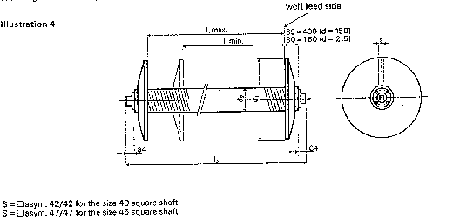 |  | L1:  Distance between flanges – min/max  L2:  Overall length of centerpiece
Warp-knitting beam TKB | 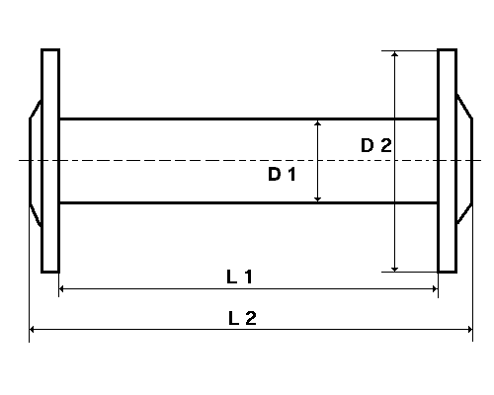 |  | D 1 – L 2:  Various measurements according to drawing
Bales |  | 